PIE CHARTS
Pearson Edexcel - Thursday 4 June 2020 - Paper 2 (Calculator) Foundation Tier

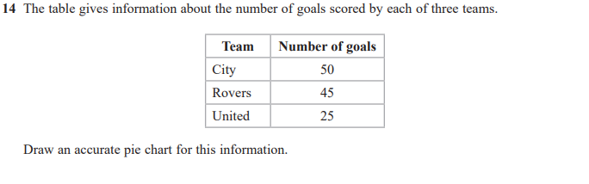
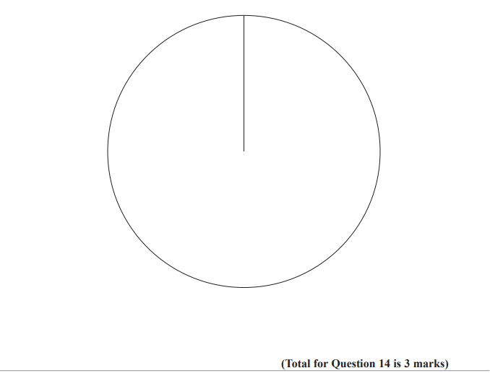

Pearson Edexcel - Monday 12 November 2018 - Paper 3 (Calculator) Foundation Tier

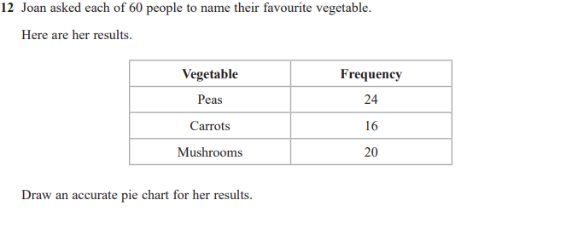
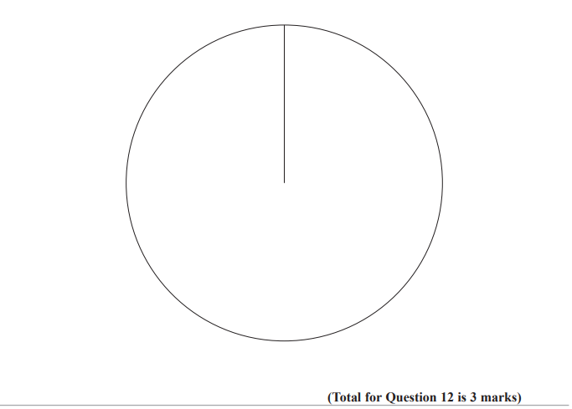

Pearson Edexcel - Thursday 7 June 2018 - Paper 2 (Calculator) Foundation Tier

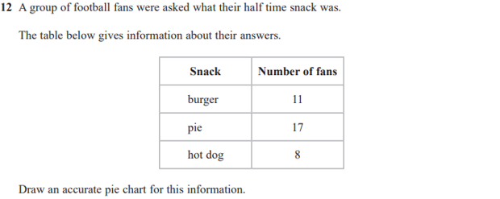
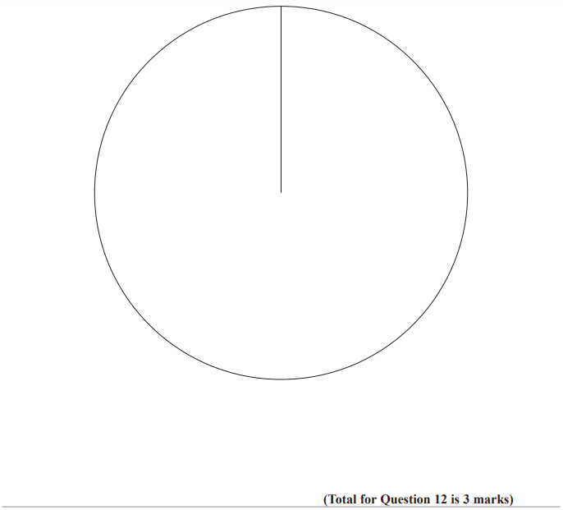
Pearson Edexcel - Monday 6 November 2017 - Paper 2 (Calculator) Foundation Tier

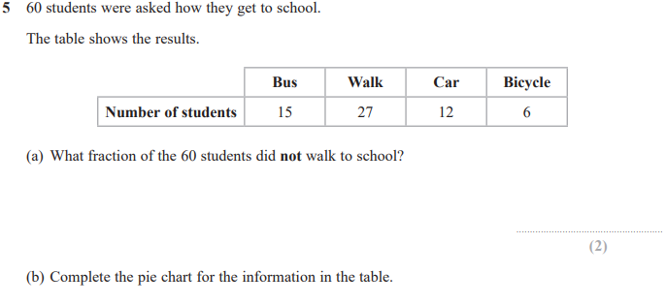
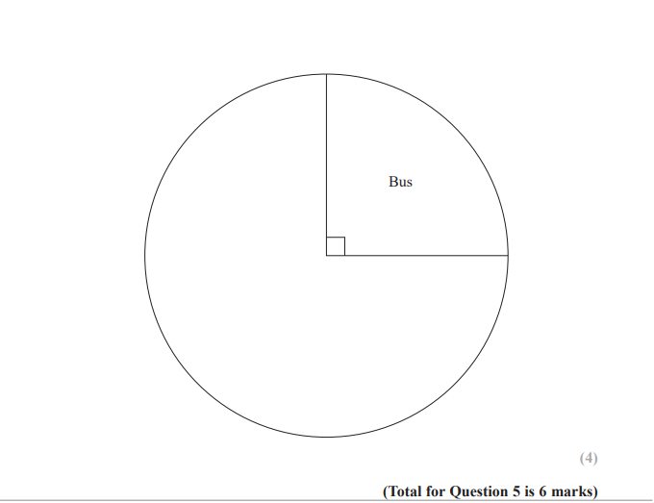

Pearson Edexcel – Specimen 2 - Paper 2 (Calculator) Foundation Tier

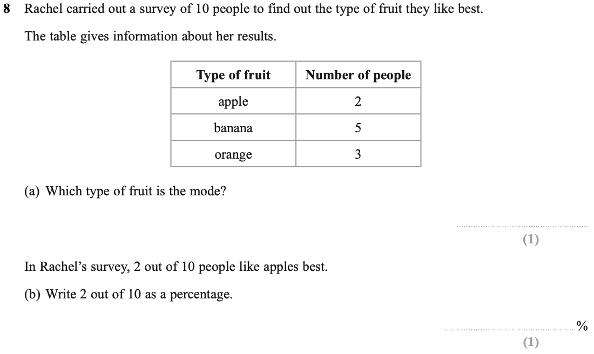

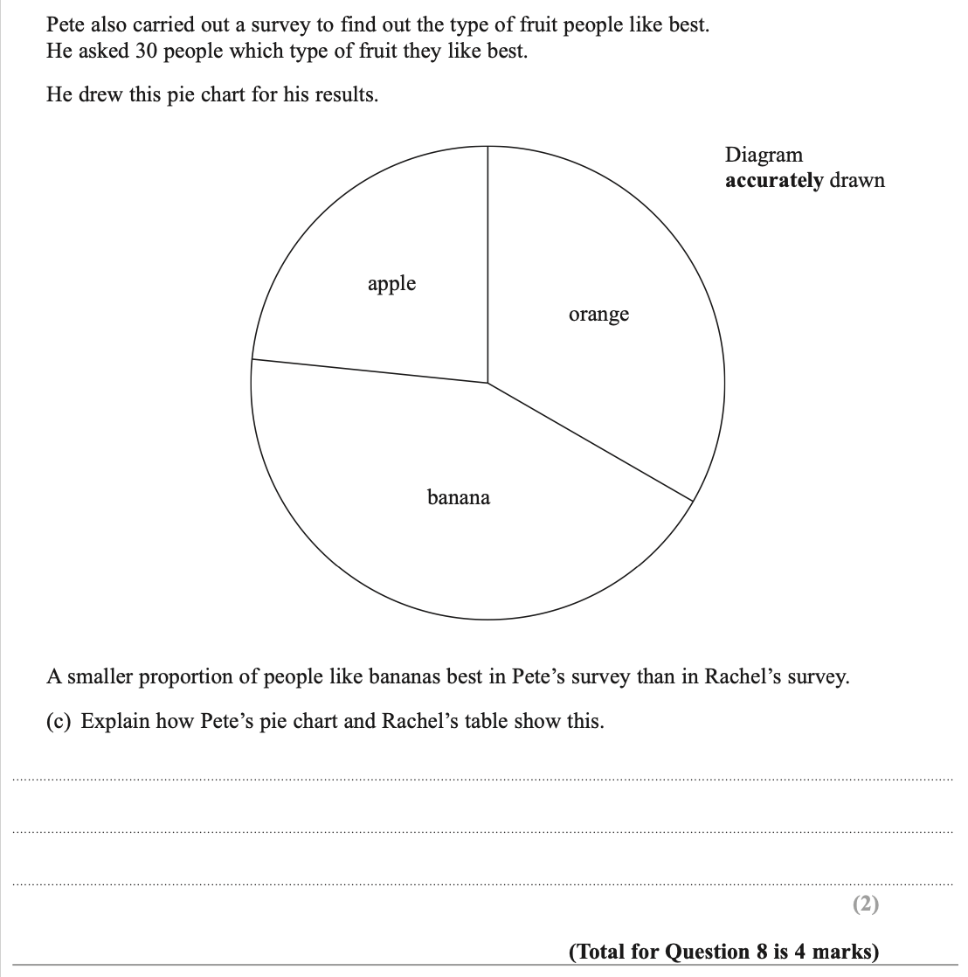

OCR Monday 11 November 2019 – Afternoon (Calculator) Foundation Tier
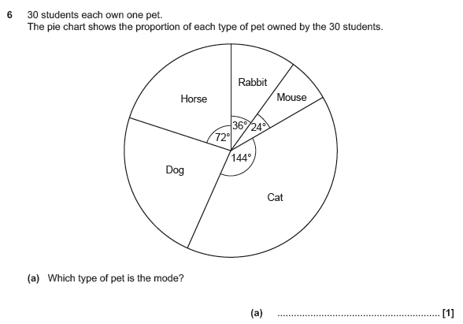

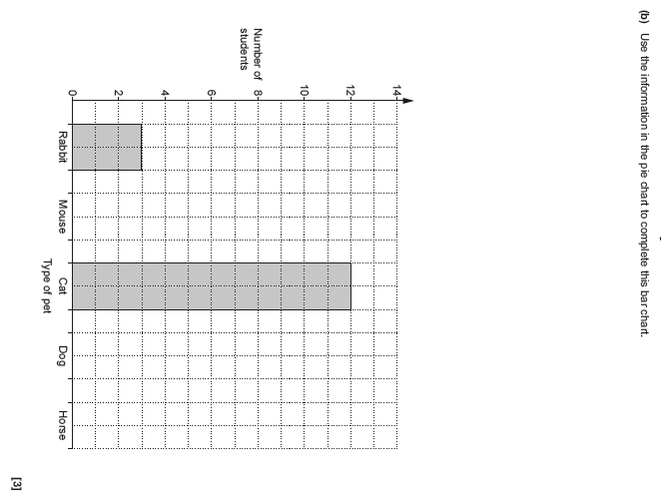

OCR Tuesday 11 June 2019 – Morning (Calculator) Foundation Tier

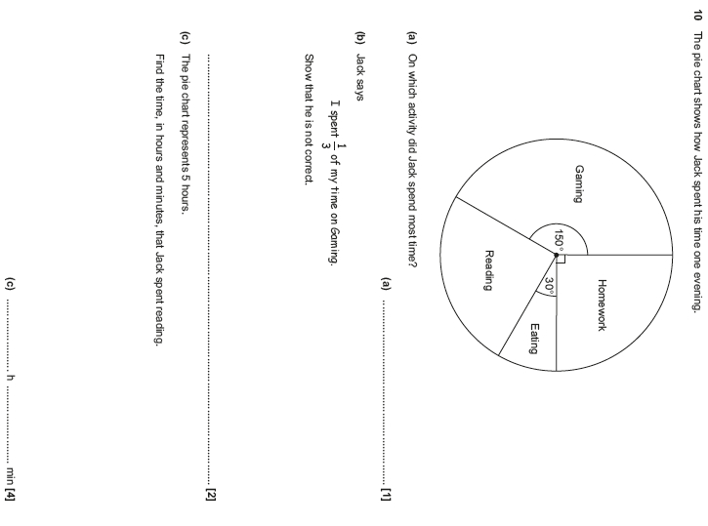

OCR Monday 12 November 2018 – Morning (Calculator) Foundation Tier
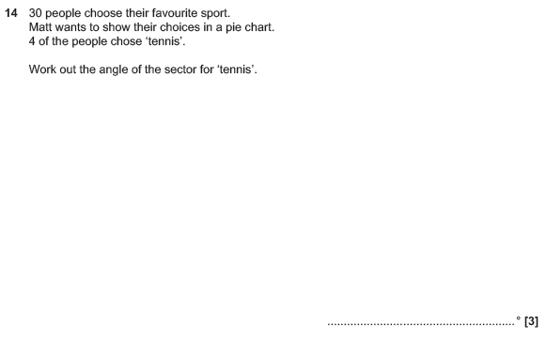

OCR Tuesday 12 June 2018– Morning (Calculator) Foundation Tier
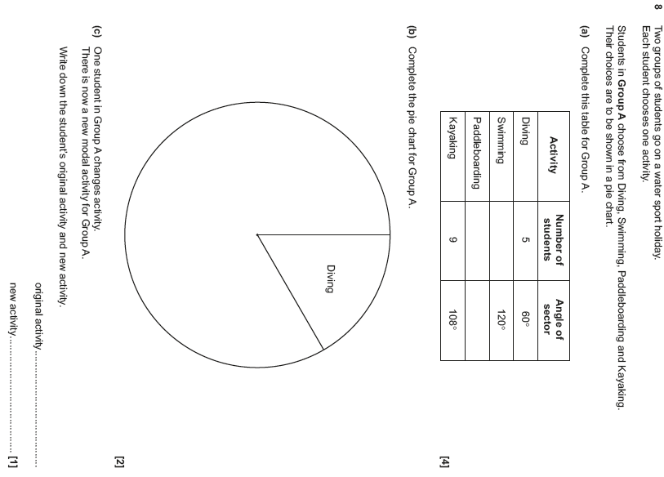

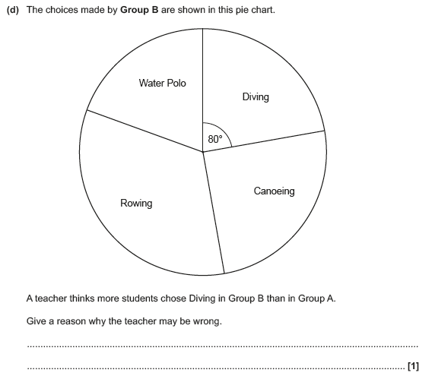

OCR Monday 6 November 2017– Morning (Calculator) Foundation Tier

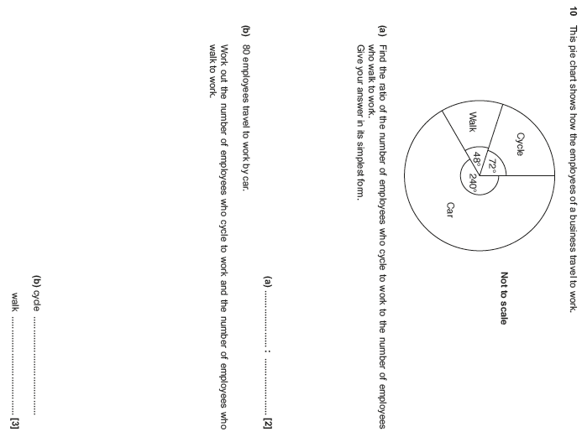

Pearson Edexcel – Sample Papers - Paper 3 (Calculator) Foundation Tier

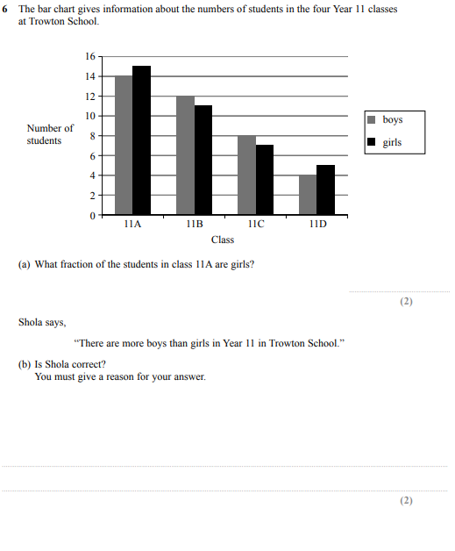

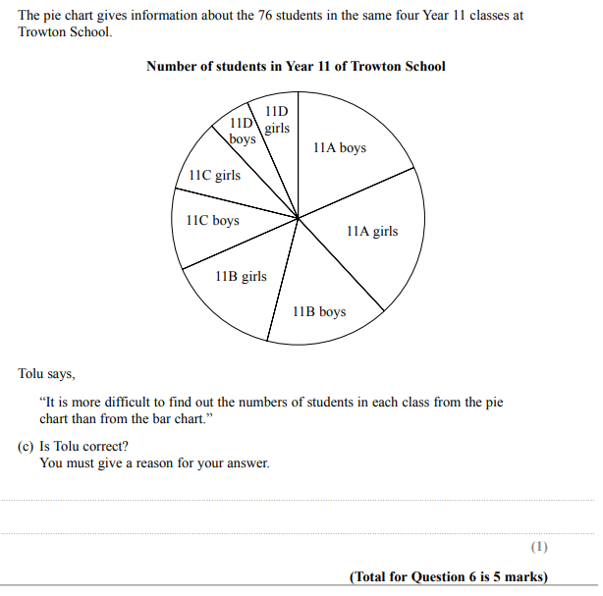

OCR Thursday 25 May 2017 – Morning (Calculator) Foundation Tier

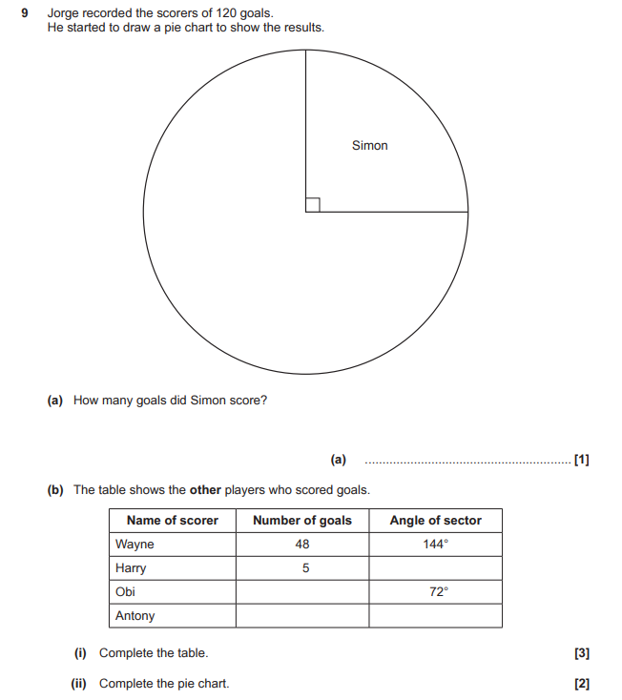

OCR Tuesday 13 June 2017 – Morning (Calculator) Foundation Tier

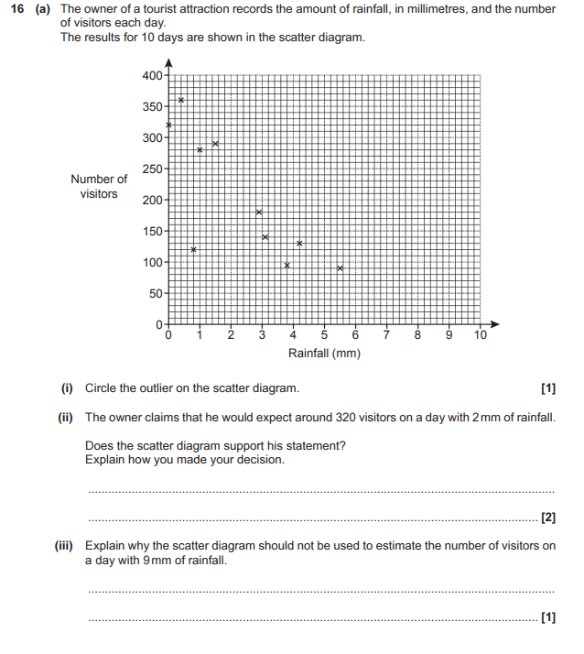

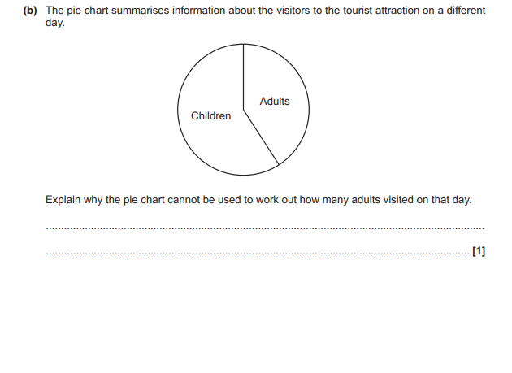

OCR Sample Question Paper 3 – Morning/Afternoon (Calculator) Foundation Tier

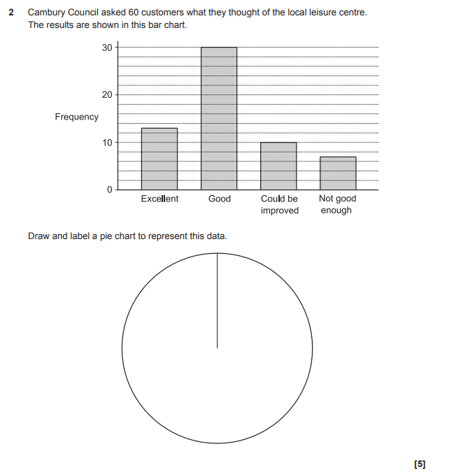

AQA Monday 8 June 2020 – Morning (Calculator) Foundation Tier

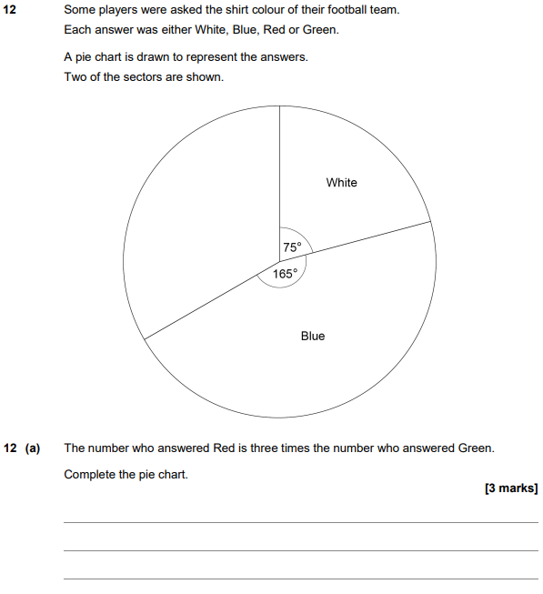

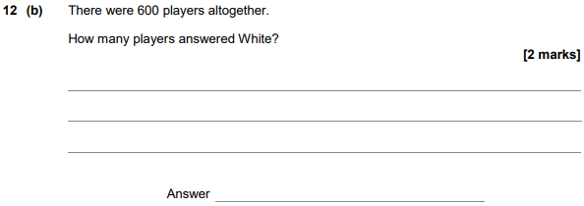

AQA Tuesday 12 June 2018 – Morning (Calculator) Foundation Tier

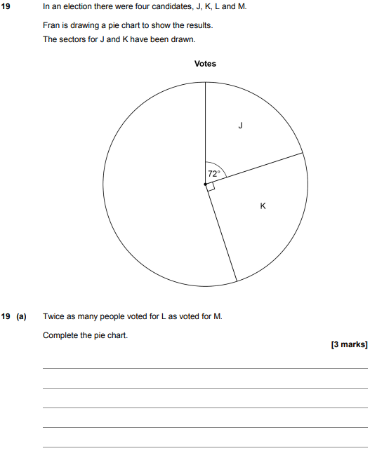
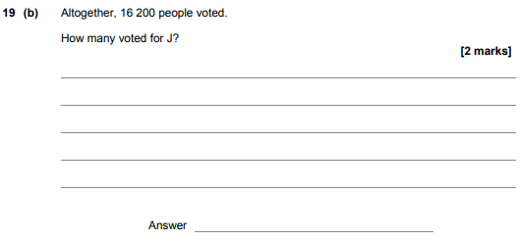

AQA Thursday 2 November 2017 – Morning (Non-Calculator) Foundation Tier

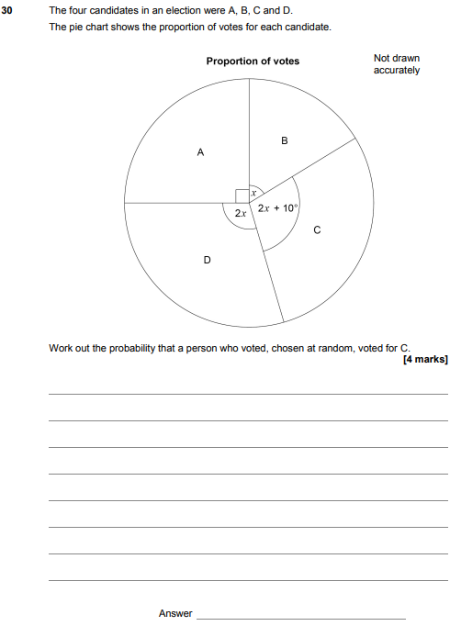

AQA Thursday 8 June 2017– Morning (Calculator) Foundation Tier

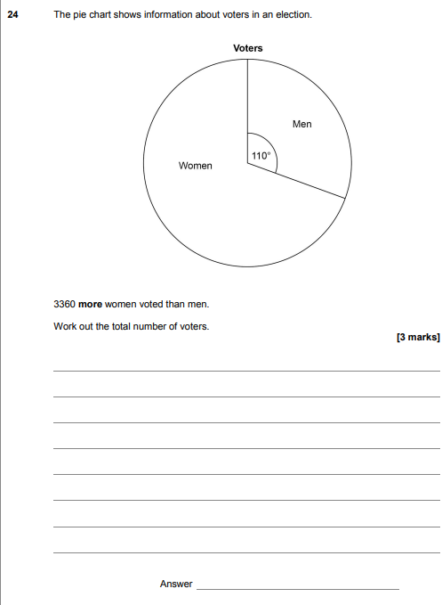

AQA Sample Paper 2– Morning (Calculator) Foundation Tier

